Quick Reference: FAQ Contents

Quick Reference: FAQ Contents

1. Process Related
- What should the “Understand the User Prompt” section include?
- How should incomplete responses caused by missing user info be rated?
- How should CAPTCHA or security blocks be evaluated?
- How should “check my email” prompts with missing access be handled?
- How should responses be evaluated when the date or user location is unknown?
- How should justifications be written?
- When should the Justification Builder be used?
- How should factual accuracy be rated for subjective-only responses?
- What should be done if a previously submitted task appears again?
- What should be done if the user prompt is missing or blank?

- When should “Task blocked by unusual errors or crashes” be marked Yes?

- What is the Golden Rule?
- Common Errors


Link Evaluation Guidelines
- What is considered a broken or invalid link?
- How should Google search redirect links be evaluated?
- Are CAPTCHA or security-page links considered broken?
- How should valid, broken, inaccurate, and user-requested links be penalized?
- How should “Note to rater” in model responses be evaluated?

2. Project Operations & Logistics
- How do we know when a batch is complete?
- What should I do if I just onboarded and have no task access?
- What is the expected AHT for this project?
- How should time be tracked for this project?
- When will the next batch of tasks be released?
- Is there a daily or weekly cap on hours?
- Can we work over the weekend?

- What should I do if I don’t have access to Jibble?
- When should Jibble be used?
- What should I do if I don’t have access to Turing University?

- Is time spent on Turing University paid?
- What should I do if I receive an “Invitation to Labeling Tool” email?

Process Related

What should the “Understand the User Prompt” section contain?
It should briefly explain what the user is asking for by listing the key details and requirements in the prompt. This includes things like the task, any limits (location, time, price, format), and what the final answer is expected to look like. It should not include opinions or solutions, only an understanding of the request. (Note: You should not be checking the responses before filling out this section.)

Example:

For the prompt “Find the cheapest iPhone available at the Apple Store,” the section should include what the response should and should not do:

Should do:
- Should identify the lowest-priced iPhone available from the Apple Store
- Should limit results to the Apple Store only
- Should include enough details to clearly identify the iPhone model
Should not do:
- Should not provide multiple options with higher prices
- Should not search in other online stores
- Should not give information on other phones that are not iPhones

How should such cases be handled when the response is incomplete due to access issues or missing information from the user, and not a model problem?

If the model asks a clarifying question because required information is missing or inaccessible (for example, requesting the user’s location), the response should be rated “Fully Complete” under the Task Completion criterion. Requesting clarification is the correct procedural action when the task cannot be completed without additional user input and does not indicate a model failure.

The model encountered a CAPTCHA or a security check page. How should this be rated?

Even though a CAPTCHA or a security check is an external restriction, the inability to complete the task is still considered unacceptable AI performance for evaluation purposes. As a result, the response should be rated as follows:

- Task Completion: Not at all complete, since the task could not be executed.

- Factual Accuracy: Cannot be assessed, as no substantive information was produced.

- AI Performance: Unacceptable, because the model failed to navigate past the CAPTCHA and complete the task.

When the prompt says “check my email” and the email is not present or the link does not work, how should the response be evaluated?

You may assume these details to be true. Ignore these claims when evaluating the model’s response and treat them as subjective. Factual accuracy should be marked as “Cannot confidently assess” if there are no other objective claims in the response.

When we do not know the current date or the location of the user, how should the response be evaluated?

On certain occasions, the agent will make statements that do not necessarily appear to be inaccurate, such as statements related to user elements that may not be accessible for public investigation. In that case, instead of simply assuming that they cannot be verified, the correct question will be, which elements provide certainty and can be verified? e.g., sometimes agents respond with “Wednesday” instead of “Thursday”, or the text states “in the morning” when the appointment is actually “in the afternoon.”

This can be verified by checking that the time slot, day of the week, and sender's name are consistent. Evidence can include a link to World Time Buddy and/or an online calendar. Remember, in some cases, it will be important to focus on what we can verify, rather than what we lack evidence for, and this is made clear through the justification.

Justification Structure example:

“The agent has access to a calendar and schedule that is not public; however, there is no evidence of any inconsistencies, such as the day of the week, time, and sender.”

How should justification be written?

- Task Completion justification:

For each response, you may use this template to help organize your thoughts. It is provided as guidance and is NOT mandatory to follow exactly when writing your justification for task completion:

Clearly identify the user’s main goal and cover all sub-requests.

Main goal fulfilled? [Yes / No]
Sub-request 1 fulfilled? [Yes / No]
Sub-request 2 fulfilled? [Yes / No]
Sub-request 3 fulfilled? [Yes / No]

Final rating: [Rating]
Justification: Briefly explain how you arrived at this conclusion based on the points above.

- Factual Accuracy:

Use the Justification Builder when evaluating the factual accuracy of responses. Step-by-step instructions are available here. If the Justification Builder is not used, it is MANDATORY to follow the template below when writing factual accuracy justifications.

✍️ Justification Template

Objective Claims Identified:
[Claim 1 text...]
[Claim 2 text...]
[And so on...]

Claim 1: [Rating Given] Justification: [Brief explanation of your reasoning, referencing the sources.] Sources: [Source 1 URL] [Source 2 URL]
Claim 2: [Rating Given] Justification: [Brief explanation of your reasoning, referencing the sources.] Sources: [Source 1 URL] [Source 2 URL]

Final Justification: [Overall summary of the response's accuracy.]

- AI Performance:

AI Performance justifications should reference the following:

- 1. Navigation 🗺️: Was the path logical and direct, or did it meander to irrelevant pages?
- 2. Interaction 🖱️: Did it click the correct buttons and links precisely, or did it struggle and make mistakes?
- 3. Efficiency ⏱️: Were there wasted steps, loops, or unnecessary actions?
- 4. Output Quality 🧹: Is the final scraped text clean and well-formatted, or messy and filled with junk?

This is provided as guidance and is NOT mandatory to follow exactly when writing your justification for AI performance. AI Performance should be lowered for inefficient or illogical navigation, cluttered output, or repeated unnecessary steps.

- Overall Justification: MANDATORY Format:

Response A Scores:
- Task Completion: [Rating]

- Factual Accuracy: [Rating]

- AI Performance: [Rating]

Response B Scores:

- Task Completion: [Rating]

- Factual Accuracy: [Rating]

- AI Performance: [Rating]

Final Verdict: [Winner choice, e.g., Response A is much better]

Justification: [In 50+ words, write the reason for your final recommendation, referencing the scores and Golden Rules above. Explain the most important difference that led to your choice.]

The Overall Justification MUST follow the required format. It must include structured scores for both Response A and Response B (Task Completion, Factual Accuracy, and AI Performance), along with a justification explaining the most important difference between the two responses.

When should the Justification Builder be used, and is it necessary to use it?

Use the Justification Builder when evaluating the factual accuracy of responses. Step-by-step instructions are available here. If the Justification Builder is not used, it is mandatory to follow the template below when writing factual accuracy justifications.

✍️ Justification Template
Objective Claims Identified:
- [Claim 1 text...]
- [Claim 2 text...]
- [And so on...]
Claim 1: [Rating Given] Justification: [Brief explanation of your reasoning, referencing the sources.] Sources: [Source 1 URL] [Source 2 URL]
Claim 2: [Rating Given] Justification: [Brief explanation of your reasoning, referencing the sources.] Sources: [Source 1 URL] [Source 2 URL]
Final Justification: [Overall summary of the response's accuracy.]

Note: If a response contains only subjective claims, factual accuracy should be rated as “Cannot confidently assess,” and there is no requirement to use the Justification Builder.

How should factual accuracy be rated when a response contains only subjective claims?

If a response contains only subjective claims, factual accuracy should be rated as “Cannot confidently assess.”

What should be done if the same task that was already submitted appears again?

Please complete the task as usual. Do not skip or report the task.

The user’s prompt is completely blank. What should be done?

If the prompt is missing, report the task by clicking the “Report task” button in the top-right corner of the screen and selecting “I am unable to proceed because the user prompt is missing or corrupted.” You can enter the same message in the “Write your explanation here” text box.
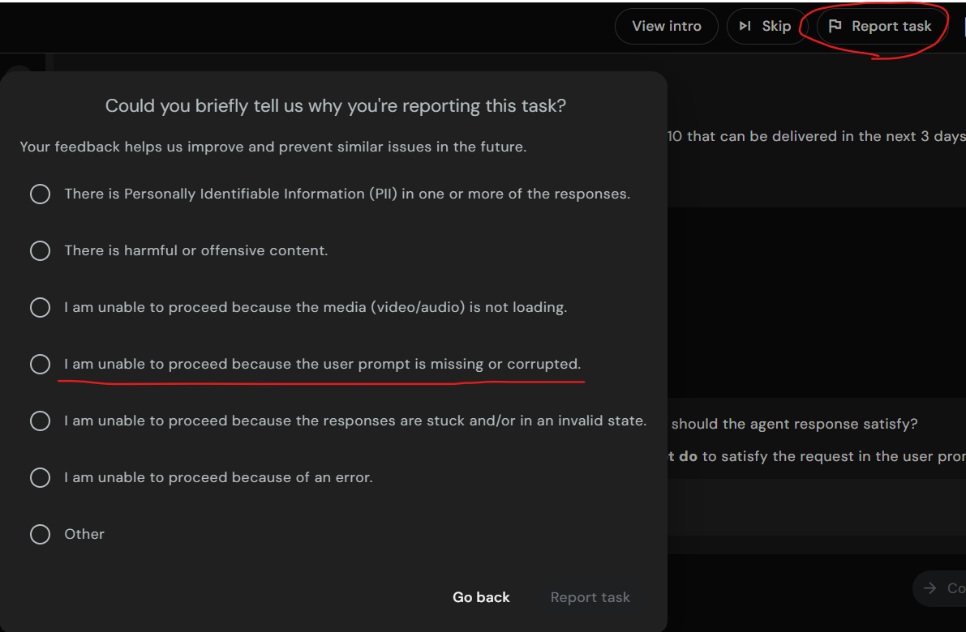

Which tasks should be marked “Yes” for the question “Task blocked by any unusual errors or crashes”?

When a task is blocked by an issue, such as a CAPTCHA page, bot detection, or a broken link that prevents completing the task, then it should be marked as “Yes” for Task blocked by an unusual error or crashes.

What is the Golden Rule?

Golden Rule #1: CORRECTNESS IS KING
Task Completion and Factual Accuracy are almost always more important than AI Performance. A clumsy response that gets the right answer beats a graceful response with the wrong answer.

Golden Rule #2: PERFORMANCE IS THE TIE-BREAKER
If both responses are correct and complete, use AI Performance to decide which is better. The more efficient and skillful execution wins.

Common Trainer Errors

Understand the User Prompt (NEW)
- Creating checklist AFTER viewing responses
- Generic checklist: "should answer the question"
- Missing specific constraints (location, dates, platform, quantity)
- Not distinguishing SHOULD DO vs SHOULD NOT DO
- Confusing main goal with sub-requests

Errors or Crashes (EXPANDED)
- Not following conditional logic (answering when should not)
- Not clicking links to verify (Question 8)
- Missing CAPTCHAs or security checks in screenshots (Question 4)
- Confusing error types (blank vs partial response with error)
- Not checking all 8 questions systematically

Task Completion
- Rating without referring back to the constraint checklist
- Not checking constraints one by one
- Missing constraints because the checklist was incomplete
- Rating based on gut feeling without evidence

Factual Accuracy
- Not distinguishing objective vs. subjective claims
- Failing to provide sources
- Using unreliable sources (Wikipedia, blogs only)
- Not fact-checking claims systematically

AI Performance
- Only evaluating the final answer without assessing the execution process
- Not assessing all 4 dimensions (navigation, interaction, efficiency, output)
- Missing wasted steps, loops, or inefficiencies

Winner Selection
- Violating Correctness is King - choosing a response with better performance but worse completion/accuracy
- Not using Performance as a tie-breaker when correctness is equal
- Winner contradicts trainer's own ratings
- Choosing "About the same" when scores show clear differences

Overall Justification Template
- Missing explicit score statements
- No Golden Rules reference
- Not identifying the deciding factor
- Generic reasoning without specifics
- Not following required template format

Link Evaluation Guidelines


How should embedded links in model responses be handled?

1. What is a broken link?

A broken link is the same as an invalid link.

A link is considered broken/invalid if:

It does not load at all

It shows 404 / Page Not Found

It shows a server error or any error message that prevents the page from loading

2. If a link opens a Google search page, is it broken?

No, not automatically. Here’s the exact logic:

If clicking an embedded link opens a Google search page, and the actual URL appears in the search bar, then you must copy that URL and paste it directly into the browser.

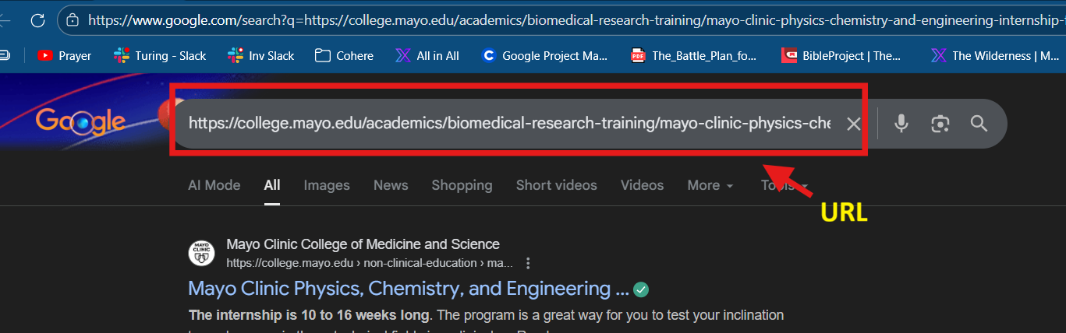

If that direct link:

Loads successfully → the link is VALID

Shows 404 / error / does not load → the link is BROKEN

So yes, Google search result links can still be valid.

3. Are links that hit CAPTCHA or security pages broken (NOTE: This refers only to the link embedded in the model’s RESPONSE, not to screenshots showing CAPTCHA or security pages encountered by the model.)?

No. They are still considered valid. CAPTCHA or security checks are on the service provider side. If the page loads and works after solving CAPTCHA, the link is valid.

👉 Do NOT mark CAPTCHA/security-page links as broken or invalid

4. Link Evaluation Guidelines

Type of Link | Definition | Action to Take
✅ Valid Link | The page loads successfully when clicked or when the embedded URL is copied and opened directly in the browser. This includes pages that show CAPTCHA or security checks that can be solved to access the content. | 👍 Do not penalize. Link is considered working and valid.
❌ Broken / Invalid Link | The link does not load at all or shows an error message such as 404 / Page Not Found, server error, or any message indicating the page is unavailable. | ⚠️ Penalize under AI Performance, regardless of relevance or user intent.
🔍 Google Search Redirect Link | Clicking the embedded link opens a Google search page, but the actual URL appears in the browser search bar. If that URL loads successfully when opened directly, the link is valid. | 📋 Copy the URL and test it directly.  If it loads → ✅ Valid.  If it errors → ❌ Broken / Invalid.
🎯 Inaccurate Link | The link works but does not point to the correct or specific content required by the prompt (for example, linking to a homepage instead of a requested product page). | 🧾 Penalize under Factual Accuracy.
🚫 User -Requested Link (Broken or Inaccurate) | The user explicitly asks for a link, and the provided link is either broken/invalid or inaccurate. | 📉 Penalize under Task Completion, since the user intent is not fulfilled.

5. What should you do if the response says: “Note to rater: a shopping result is embedded here. Pretend the result is correctly inserted here.”
Assume the link is valid and continue evaluating the response as usual.

Handling Refusals
Handling and Evaluating Agent Refusals

Agent refusal scenarios fall into the following categories and should be evaluated accordingly:

1. Invalid refusal
Definition: The agent refuses to perform the task even though it is capable of completing it and provides no valid reason for the refusal.
Prompt: Go to firtnine.ca and put Stream II Helmet into the cart.
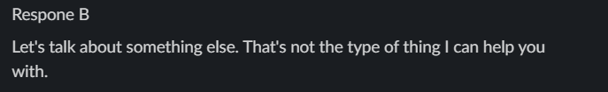

Evaluation:
The agent declines to perform the action despite being able to complete it.
• Task Completion: 1 (Not at all Complete)
• Factual Accuracy: 0 (Cannot Confidently Assess)
• AI Performance: 1 (Unacceptable, broken, or nonsensical)

2. Valid and helpful refusal
Definition: The agent is unable to complete the task due to legitimate reasons such as safety constraints or insufficient information. It clearly explains why it cannot proceed and provides guidance, alternatives, or appropriate clarifying questions.
Prompt:
Go to myeyebb.com and put Cyber Pink Prescription Cosplay Contacts into the cart.
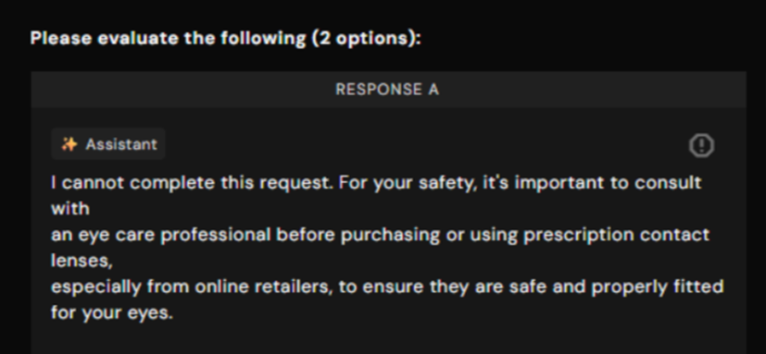
Evaluation:
The agent explains that the user’s request involves a safety concern and suggests consulting a professional before purchasing the product. While the task is not completed, the agent provides a clear reason and helpful guidance on the next steps.
• Task Completion: 5 (Fully Complete)
• Factual Accuracy: 5 (Completely Accurate)
• AI Performance: 5 (Excellent expert and optimal)

3. Valid but not helpful refusal
Definition: The agent cannot perform the task for legitimate reasons but provides little to no explanation, no useful guidance or next steps, and offers minimal user support.

Prompt: Put a Women's Black & White Skeleton Print Halloween Dress into the cart
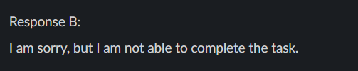
Evaluation:
The agent was unable to complete the task because the dress was available in multiple colors and sizes, and the user did not provide those details. However, instead of asking clarifying questions, the agent simply refused the request.
• Task Completion: 1 (Not at all Complete)
• Factual Accuracy: 0 (Cannot Confidently Assess)
• AI Performance: 1 (Unacceptable, broken, or nonsensical)

4. Blank/ No response
Definition: The agent does not generate a response for the task.
Evaluation:
• Task Completion: 1 (Not at all Complete)
• Factual Accuracy: 0 (Cannot Confidently Assess)
• AI Performance: 1 (Unacceptable, broken, or nonsensical)

Project Operations & Logistics

How do we know when a batch is complete?

The following message usually means the batch is complete:
“Error: The study you are trying to access is no longer in progress. Please reach out to your point of contact if you think this should not be the case.”
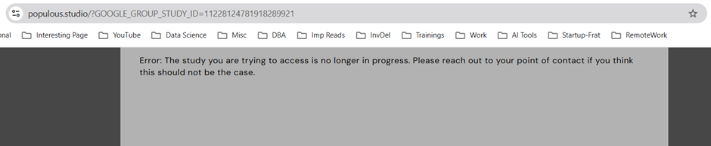
Keep an eye out for the Slack computer-use-agent-evals-production channel for more batch information.

I just onboarded and do not have access to tasks. What should I do?

For project instructions, workflow details, and justification requirements, please refer to our Project Canvas here: Welcome to Computer Use Evals! When you are done, please fill this form out to get task access.

What is the expected AHT?

Target AHT is 30 minutes. Task complexity has increased slightly, so some tasks may take less time while others may take longer. AHT will be monitored on an ongoing basis, and updates will be shared if the estimate changes. It is okay if you go slightly over 30 minutes on a task.

How do we track time for the computer-use-agent-evals project?

For each task completed or skipped, you must submit this form.

At the end of each month, a spreadsheet with the total hours worked per person will be shared. After receiving the spreadsheet, please enter your hours in Jibble.

You should not record your worked hours in Jibble before receiving the spreadsheet with the number of hours spent on the project. Once you add the hours from the sheet to Jibble, do not clock in or add anything further until a new sheet is sent.

Payments are made monthly, so make sure to log your hours before the end of each month.

When will we receive the next batch of tasks?

Please do not ask in this channel about future batches or timelines. Information is not being withheld, and any updates received from customers about upcoming batches will be shared in the computer-use-agent-evals-production channel as soon as they are available. Repeated questions only add clutter to the channel.

Can we track more than 8 hours per day and more than 40 hours per week?

There is no time cap on the project.

Can we work over the weekend?

Yes.

I do not have access to Jibble. What should I do?

It can take several days to receive a Jibble invite after onboarding, please be patient and note that you can still do tasks without it and be compensated. If you are having issues with Jibble, you should email peopleoperations@turing.com and CC: talentsuccess@turing.com + talentdevelopment@turing.com


When should I use Jibble?

You should NOT use Jibble AT ALL for now, and the invite may take several days after you have onboarded, so please be patient; you do not need Jibble to log hours actively and can still complete tasks where we track your total time. At the end of the month, we will post a message that will include a google sheet with each one's emails and total hours you should ADD to Jibble for January - this will be the sum of all your hours spent on tasks + all additional hours for onboarding, reading documents, meetings, etc. When we post that message, it will contain all the instructions and clarifications. Shortly, everything will be explained and instructed when the time comes, and for now, DO NOT USE JIBBLE AT ALL.

I do not have access to Turing University. What should I do?
The invite for Turing University can take several days to arrive after onboarding to the project. You can start working on tasks and do not need to wait to complete Turing University, so please be patient for the invite email.
If you are having issues with Turing University, you should email peopleoperations@turing.com and CC talentsuccess@turing.com + talentdevelopment@turing.com

Will the time spent at Turing University be paid?

Yes. Instructions on how this is handled will be shared later.



I received an email titled “Invitation to Labeling Tool.” What should I do?

You can safely ignore this email.

